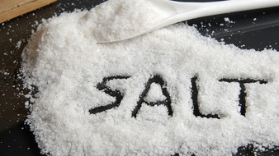
FOOD | ROLE IN BODY | HARMFUL ASPECTS  (due to over consumption) | ALTERNATIVES | FOODS TO BE AVOIDED
SALT (SODIUM CHLORIDE) | - NaCl is present in body 0.9g/100mL  - Maintains red blood cells  - Maintains water in body  - Helps in transportation of material is body  - Helps in heart functions  - Important part of blood plasma  - Maintains acidity level of body | - Called “ stress food”  - More salt deprives off calcium from bones  - Increases body weight  - Causes lungs problems  - Increased blood volume (swelling of body parts)  - Extra Na without water causes muscle cramps, vomiting, dizziness  - Affects kidney and cause formation of kidney stones | - Mineral salt  - Black salt  - Potassium salt | - Chinese foods  - Popcorns  - Instant soups  - Roasted & salted nuts  - Canned vegetables  - Pickles  - Cured meat & fish
Description:
- In summer, spots on our dresses are made due to Sodium Chloride.
- How salt increases body weight?
If kidneys are unable to excrete proper amount of salt due to improper supply of blood or weakness, salt starts to store in kidneys as well as water is also stored there in appropriate ratio of blood. Hence, body weight starts increasing.
- Potassium salt is recommended for high blood pressure patients
References:
- www.healthaliciousness.com
- http://healthyeating.sfgate.com/
- Book: Foods that are killing you slowly but steadily (M.K. Gupta)

