Assignment Title:

MANGO: TO CURE DISEASES

Submitted by:

Faisal Hayat
Roll # 01
B.Sc. (Hons.) Food Science and Technology
Semester 7th(Self Support)
Email: faisalhayatuos@gmail.com

Submitted to:
Dr. Saqib Jabbar
Assistant professor
Institute of Food Science and Nutrition
University of Sargodha, Sargodha

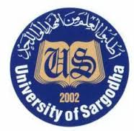
INSTITUTE OF FOOD SCIENCE AND NUTRITION
UNIVERSITY OF SARGODHA
SARGODHA
MANGO: TO CURE DISEASES

- Lower Cholestrol
- Promote Good Eyesight
- Prevents Cancer
- Boost Immune System
- Heat Stroke Remedy
- Good For Normalizing Insuline Level

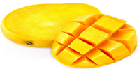

Prepared By: Faisal Hayat
Roll # 01 (S.S) 7th semester
B.Sc (Hons.) Food Science and Technology
Institute of Food Science and Nutrition
University of Sargodha, Sargodha
pakistan
E.mail: faisalhayatuos@gmail.com `
MANGO AND CANCER

Mango fruit is rich in dietry fiber, vitamins, minerals and poly-phenolic flavonoids antioxidant compounds. According to new research study, mango fruit has been found to protect against colon, breast, leukemia and prostate cancers.
Important Nutrients in Mango that Control Cancer:
Vitamin-C: Vitamin-C is an antioxidant that help to prevent the formation of cancer-causing nitrogen compounds.
Quercetin: It has anti-inflammatory properties, which is good, because inflammation is bad.
How Mango Helps in Controlling Cancer Diseases:
Quercetin binds to excess iron in our body, removes it from tissues, and prevents its absorption. This process is called chelation. This is critical as iron can be a key ingredient in cancer cell growth. Quercetin has the ability to steal the iron from cancer cell which can stop their growth and induce cell death. Vitamin-C interacts with iron and other metals to create Hydrogen peroxide. In high conc. hydrogen peroxide damages the DNA and mitochondria of cancer cells, shuts down their energy supply, and kill them outright.

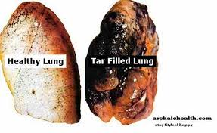
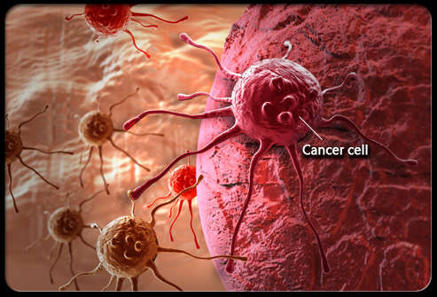

Quantity of Important Nutrients in Mango that Control Cancer
Sr. # | Name of Compounds | Quantity (mg/kg)
1. | Vitamin C | 28.7
2. | Quercetin | 65.3

References:
http://www.drwhitaker.com/iv-vitamin-c-kills-cancer-cells/
http://mangodash.blogspot.com/2015/03/benefits-of-mango-fruit-for-cancer.html
http://onlinelibrary.wiley.com/doi/10.1111/j.1541-4337.2008.00047.x/full
http://www.chrisbeatcancer.com/most-powerful-flavonoid-in-the-galaxy/
http://healthimpactnews.com/2013/17-reasons-why-you-need-a-mango-every-day/#sthash.nrrF84nv.dpuf
http://www.joybauer.com/cancer/how-food-affects-cancer.aspx
https://books.google.com.pk/books?id=iPFokL0MuswC&pg=PA303&lpg=PA303&dq=quantity+of+vitamin+c+in+mango+that+control+cancer&source=bl&ots=vIEzrCXigQ&sig=QPGE1nDav4YRapYHvJ9QoE5PEIA&hl=en&sa=X&ved=0CFEQ6AEwCGoVChMIvZnD0uTvyAIVJiKmCh186gl0#v=onepage&q=quantity%20of%20vitamin%20c%20in%20mango%20that%20control%20cancer&f=false

