Topic of Assignment
NUTRITIONAL VALUE OF LYCHEE

Submitted By:

Fahar Zulfiqar
B.Sc. (Hons.) Food Science and Technology (Semester-7th)
Roll No: 23 (Regular)

Submitted To:

Dr. Saqib Jabbar
Assistant Professor
Institute of Food Science and Nutrition (IFSN)
University of Sargodha, Sargodha
Institute of Food Science and Nutrition
University Of Sargodha
SARGODHA, PAKISTAN
Nutritional Value of Lychee (Litchi Chinensis) Per 100 g
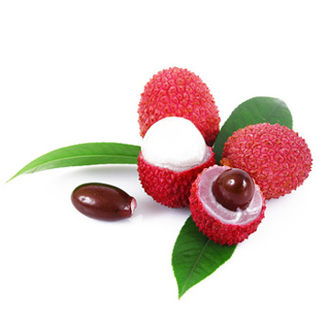
Dated: 1st October 2015
Lychee is Famous For:
- Vitamin C
- Potassium

3. Potassium
4. Beta-Carotene)
Prepared By:
Fahar Zulfiqar
Roll No.23(R)
Bsc(Hons.)FST 7th semester

Energy | 66 Kcal
Carbohydrates | 16.53 g
Total Fat | 0.44 g
Protein | 0.83 g
Dietary Fiber | 1.3 g
Vitamins
Vitamin A | 0 mg
Thiamine (B₁) | 0.011 mg
Riboflavin (B₂) | 0.065 mg
Niacin (B₃) | 0.603 mg
Choline | 7.1 mg
Pyridoxine | 0.100 mg
Folate (B₉) | 14 µg
Vitamin C | 71.5 mg*
Vitamin E | 0.07 mg
Vitamin K | 0.4 µg
Minerals
Calcium | 5 mg
Copper | 0.148 mg*
Iron | 0.31 mg
Magnesium | 10 mg
Potassium | 171 mg*
Manganese | 0.055 mg
Phosphorus | 31 mg
Selenium | 0.6 µg
Sodium | 1 mg
Zinc | 0.07 mg
Source: USDA Nutrient Database

