Assignment Title:

GARLIC: TO CURE DISEASES

Submitted by:

Asma Riaz
Roll # 14
B.Sc. (Hons.) Food Science and Technology
Semester 7th (Self Support)
Email: ahakafa@ymail.com

Submitted to:
Dr. Saqib Jabbar
Assistant professor
Institute of Food Science and Nutrition
University of Sargodha, Sargodha

INSTITUTE OF FOOD SCIENCE AND NUTRITION
UNIVERSITY OF SARGODHA
SARGODHA
SPINACH: TO CURE DISEASES
GARLIC: TO CURE DISEASES

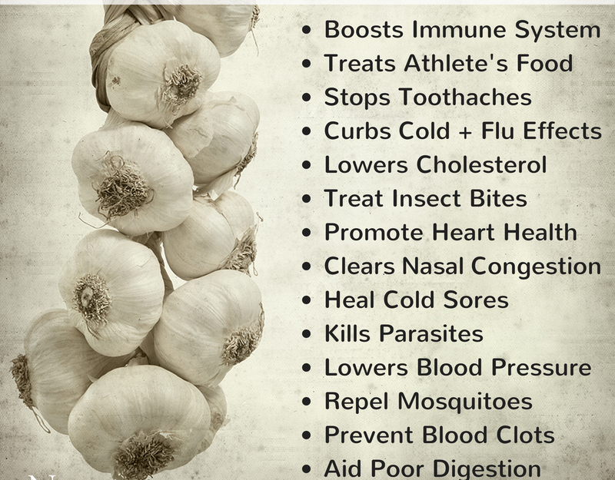

Prepared By: Asma Riaz
Roll # 14 (S.S) 7th semester
B.Sc. (Hons.) Food Science and Technology
Institute of Food Science and Nutrition
University of Sargodha, Sargodha
Pakistan
Email: ahakafa@ymail.com
GARLIC AND HIGH BLOOD PRESSURE
Garlic (Allium Sativum L) is a plant in the Allium (onion) family. Garlic is rich in compounds like Allicin, Sulphur, Zinc and Calcium that have health benefits, beauty benefits as well as antibiotic and antifungal properties. It is also a rich source of a mineral known as selenium. Selenium is known to fight cancer and it works with vitamin E in the body to boost antioxidant power. Garlic also acts as a blood thinner due to its salicylate content. This enables proper blood flow and enhances circulatory health.
Important Nutrients in Garlic that Control High Blood Pressure:
Allicin: Garlic releases an enzyme called alliinase that catalyzes the formation of allicin. Allicin rapidly breaks down to form a variety of organosulfur compounds.
How Garlic Controls High Blood Pressure:
In high blood pressure blood flows through blood vessals
(artries) at higher pressure than normal. Allicin is a substance
which helps in relexing blood vessals while also reducing any
pressure and damage effecting blood. It also interferes with the
effect of angiotensin enzyme in elevating blood pressure
and smoothly contracting muscles. Allicin decreases blood vessel
stiffness through facilitation of nitric oxide (NO) release.
Nitric oxide relaxes blood vessels and thereby, bring a reduction
in the total blood pressure.

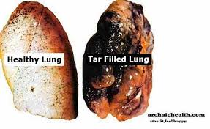
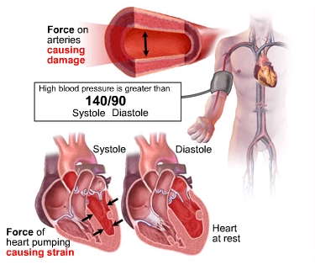

Quantity of Nutrients in Garlic that Control High Blood Pressure
Sr. # | Name of Compounds | Quantity (Per Clove)
1. | Allicin | 3.6 mg

References:
- http://www.njnaturopath.com/newsletter/garlic1.html
- http://www.naturalnews.com/027195_garlic_high_blood_pressure.html
- http://www.naturalblaze.com/2013/04/10-amazing-health-benefits-of-garlic.html
- https://en.wikipedia.org/wiki/Allicin
- http://www.garlicheals.com/how-much-allicin-in-one-garlic-clove/

