Topic of Assignment

NUTRITIONAL VALUE OF ONION

Submitted By:

Hafiza Rahma Saman
B.Sc. (Hons.) Food Science and Technology (Semester-7th)
Roll No: 21(Regular)
Email: rahma.saman12@gmail.com

Submitted To:

Dr. Saqib Jabbar
Assistant Professor
Institute of Food Science and Nutrition (IFSN)
University of Sargodha, Sargodha
Institute of Food Science and Nutrition
University Of Sargodha
SARGODHA, PAKISTAN
Nutritional Value of Onion (Allium cepa) Per 100 g
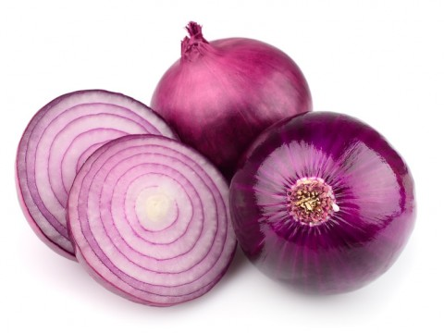
Onion is Famous For:
1. Vitamin C
2. Potassium
Prepared By: Hafiza Rahma Saman

Dated: 3rd October 2015
Energy | 40 Kcal
Carbohydrate | 9.36 g
Total fat | 0.1 g
Protein | 1.1 g
Dietary fiber | 1.7 g
Sugar | 4.24 g
Vitamins
Vitamin A | 2 IU
Thiamine (B₁) | 0.046 mg
Riboflavin (B₂) | 0.027 mg
Niacin (B₃) | 0.116 mg
Pantothenic acid (B₅) | 0.123 mg
Vitamin B₆ | 0.12 mg
Folate (B₉) | 19 µg
Choline | 6.1 mg
Vitamin C | 7.4 mg*
Vitamin E | 0.02 mg
Minerals
Calcium | 23 mg
Fluoride | 4 µg
Iron | 0.21 mg
Magnesium | 10 mg
Manganese | 0.129 mg
Phosphorus | 29 mg
Potassium | 146 mg*
Sodium | 4 mg
Zinc | 0.17 mg
Phyto-nutrients (Act as Antioxidants)
Carotene-ß | 1 µg
Crypto-xanthin-ß | 0 µg
Leutine-zeaxanthin | 4 µg
Source: USDA Nutrient Database

Refrence
https://en.wikipedia.org/wiki/Onion
http://www.nutrition-and-you.com/onion.html
http://www.richinfoods.com/health-benefits-of-onions.html

