Assignment Title:

OKRA: TO CURE DISEASES

Submitted by:

Umama Noor
Roll # 25
B.Sc. (Hons.) Food Science and Technology
Semester 7th (Self Support)
Email: cutiepieofs@gmail.com

Submitted to:
Dr. Saqib Jabbar
Assistant professor
Institute of Food Science and Nutrition
University of Sargodha, Sargodha

INSTITUTE OF FOOD SCIENCE AND NUTRITION
UNIVERSITY OF SARGODHA
SARGODHA
OKRA: TO CURE DISEASES

- Lower High Blood Pressure
- Prevent Anemia
- Help in Diabetes
- Prevention of Colon Cancer
- Improves Immune System
- Prevent Heart Diseases
- Prevention of constipation

Prepared By: Umama Noor
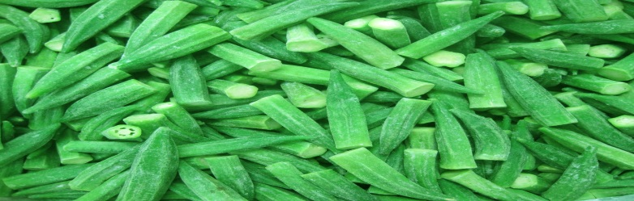
Roll # 25 (S.S) 7th semester
B.Sc (Hons.) Food Science and Technology
Institute of Food Science and Nutrition
University of Sargodha, Sargodha
pakistan
Email: cutiepieofs@gmail.com

OKRA AND COLON CANCER

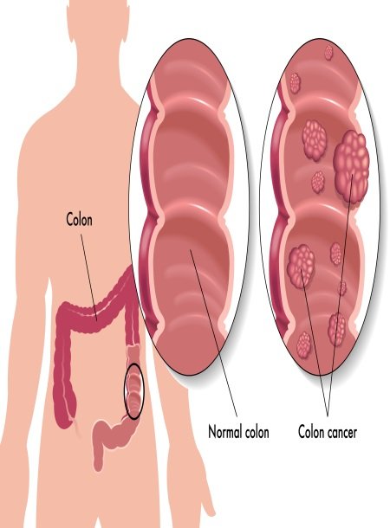
Okra is a nutritional powerhouse used throughout history for both medicinal and culinary purposes. okra is known for it’s high vitamin C, vitamin K, and folate content. Further, okra is known for harnessing a superior fiber, which helps with digestion, stabilizes blood sugar, and helps to control the rate at which sugar is absorbed.
Important Nutrients in Okra that Prevent Colon Cancer:
Dietary Fiber: Dietary fiber, also known as roughage or bulk,
includes the parts of plant foods your body can't digest or absorb.
Vitamin A: Vitamin A is also called Retinol. The function
of vitamin A among others to: maintain eyesight, prevent
nearsightedness disease to restore and maintain the body's
mucous membranes lining.
How Okra Helps in Preventing Colon Cancer:
The okra fiber reduces the time the stool spends in the intestines,
thereby limiting the colon's exposure to potential carcinogens.
It also binds existing carninogens in the intestines and absorbs
bile acids which could trigger certain bacteria to produce cancer
causing subtances.The okra fiber also promotes the proliferation
of healthy bacteria in the intestines, leaving lessroom for harmful
bacteria that could create cancerous substances.Additionally,the
vitamin A contributes to healthy mucous membranes, helping the
digestive tract to operate appropriately.

Quantity of Important Nutrients in Okra that Prevent Colon Cancer
Sr. # | Name of Compounds | Quantity (g/100 g)
1. | Dietary Fiber | 3.2
2. | Vitamin A | 375 IU

OKRA AND ANEMIA
What is Anemia?
Anemia is a condition in which your blood has a lower than normal number of red blood cells. Anemia also can occur if your red blood cells don't contain enough hemoglobin. If you have anemia, your body doesn't get enough oxygen-rich blood.
Symptoms: As a result, you may feel tired or weak. You also may have other symptoms, such as shortness of breath, dizziness, or headaches.
Important Nutrients in Okra that Prevent Anemia:
Lady finger (Okra) contains iron and folate and Vitamin K,
nutrients that help in treating and avoiding anaemia.
Iron: Iron is required for the production of red blood cells
(a process known as haematopoiesis) but it's also part of
haemoglobin.
Folate: Folate is also necessary for the production of RBC’s.
These cells carry oxygen from the lungs to other parts of
the body. A deficiency of folate can impair blood cell production.
Vitamin K: Vitamin K plays a key role in normal blood clotting.
This is important to prevent excess bleeding, which can lead to
anemia.

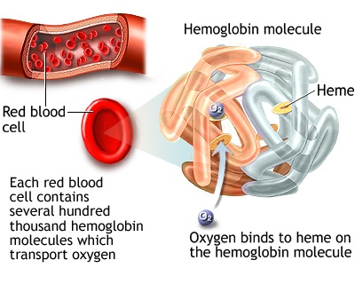

Quantity of Important Nutrients in Okra that Prevents Anemia
Sr. # | Name of Compounds | Quantity (µg/100 g)
1. | Iron | 0.80 mg
2. | Folate (B9) | 88
3. | Vitamin K | 53

References:
http://naturalsociety.com/6-okra-health-benefits-growing-cooking/
http://www.mayoclinic.org/healthy-lifestyle/nutrition-and-healthy-eating/in-depth/fiber/art-20043983
http://www.healwithfood.org/colorectalcancer/foods.php
http://www.dietburrp.com/benefits-of-lady-finger/
https://www.nhlbi.nih.gov/health/health-topics/topics/anemia
http://www.nelsonsnaturalworld.com/en-gb/uk/our-brands/spatone/iron-essentials/role-of-iron-in-the-body
http://www.whfoods.com/genpage.php?tname=nutrient&dbid=63
http://www.livestrong.com/article/390770-anemia-vitamin-k/
http://www.geocities.ws/saqibuos/nutrition9.html

