Topic of Assignment

NUTRITIONAL VALUE OF FIG

Submitted By:

Laraib Fatima
B.Sc. (Hons.) Food Science and Technology (Semester-7th)
Roll No: 25 (Regular)
Email: aleenanaqvi22@gmail.com

Submitted To:

Dr. Saqib Jabbar
Assistant Professor
Institute of Food Science and Nutrition (IFSN)
University of Sargodha, Sargodha
Institute of Food Science and Nutrition
University Of Sargodha
SARGODHA, PAKISTAN
Nutritional Value of Fig (Ficus carica) Per 100 g
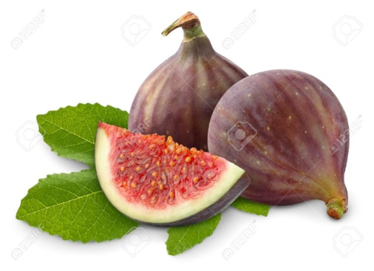
Fig is Famous For:
1. Vitamin C
2. Potassium

Dated: 10th October 2015
Prepared By: Laraib Fatima

Energy | 74 Kcal
Carbohydrate | 19.18 g
Total fat | 0.30 g
Protein | 0.75 g
Cholesterol | 0 mg
Dietary Fiber | 2.9 g
Vitamins
Folates | 6 µg
Niacin | 0.400 mg
Pantothenic acid | 0.300 mg
Pyridoxine | 0.113 mg
Riboflavin | 0.050 mg
Thiamin | 0.060
Vitamin A | 142 IU
Vitamin C | 2 mg*
Vitamin E | 0.11 mg
Vitamin K | 4.7 µg
Minerals
Calcium | 35 mg
Copper | 0.070 mg
Iron | 0.37 mg
Magnesium | 17 mg
Manganese | 0.128 mg
Selenium | 0.2 µg
Zinc | 0.15 mg
Sodium | 1 mg
Potassium | 232 mg*
Phyto-nutrients (Act as Antioxidants)
Carotene-ß | 85 µg*
Leutine-zeaxanthin | 4 µg
Source: USDA National Nutrient Database
Reference: http://www.nutrition-and-you.com/fig-fruit.html

