**Assignment Title:**

**CORIANDER: TO CURE DISEASES**

**Submitted by:**

**Sania Sheikh**

Roll # 31

B.Sc. (Hons.) Food Science and Technology

Semester 7th (Self Support)

**Email:**sania.sheikh21292@gmail.com

**Submitted to:**

**Dr. Saqib Jabbar**

Assistant professor

Institute of Food Science and Nutrition

University of Sargodha, Sargodha.



**INSTITUTE OF FOOD SCIENCE AND NUTRITION**

**UNIVERSITY OF SARGODHA**

**SARGODHA**

|  |
| --- |
| **CORIANDER: TO CURE DISEASES**        C:\Users\javed\Desktop\download.jpg  **Prepared By: Sania Sheikh**  Roll # 31 (S.S) 7th semester  B.Sc. (Hons.) Food Science and Technology  Institute of Food Science and Nutrition  University of Sargodha, Sargodha    Pakistan    Email: sania.sheikh21292@gmail.com |

**CORIANDER AND DIARRHEA**

At least three loose or liquid bowel movements per day refer to as diarrhea. It is caused by poor sanitation, bad nutrition, microbial infections etc. Improper nutrition leads to weak immune system making people more prone to diarrhea. Coriander can be used to cure diarrhea.

**Important Nutrients in Coriander that Control Diarrhea:**

**Linalool:** It is a digestive stimulant that makes digestive system

strong. It is the major component of all the essential oils found in

coriander.

**Alpha pinene:** Anti-bacterial and anti-fungal properties which

prevent from diarrhea caused by microbes.

**Beta phelandrene:** Anti-bacterial and anti-fungal properties

**Cineole:** Anti-bacterial and anti-fungal properties

**Borneol andlimonene:** Anti-bacterial and anti-fungal properties

**Dodecanal:** Natural antibiotic against diarrhea caused by

salmonella species

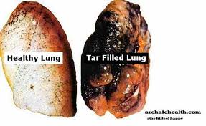

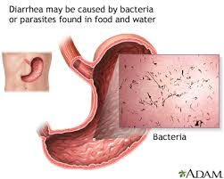

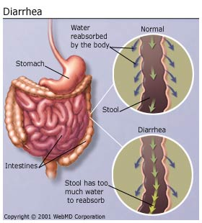

**How Coriander Works Against Diarrhea**

Coriander has certain essential oils which stimulate

digestive system like borneol, linalool and other

important terpenoids. They make the stomach strong

and help in proper functioning. Furthermore they also

relieve flatulence. Camphylobacter species are the

main cause of bacterial diarrhea but diarrhea because

of shigella, salmonella and E. coli species is also

common. Coriander contains essential oils i.e. alpha

pinene, Beta phelandrene, cineole and borneol

andlimonene that provide ease against diarrhea.

These essential oils have also anti-fungal properties.

Dodecanal is a natural antibiotic that is helpful

against diarrhea caused by salmonella.

|  |  |  |  |
| --- | --- | --- | --- |
|  | **Quantity of Nutrients in Coriander that Control Diarrhea** | | |
|  | **Total Essential Oils** | **0.8-1%** | **8-10mg/g** |
| **Sr. #** | **Name of Compounds** | **Quantity (%)** | **Quantity (mg/g)** |
| **1.** | Linalool | 72.7 | 5.82-7.27 |
| **2.** | Dodecanal | 1.32 | 1.056-1.32 |
| **3.** | Limonene | 2.3 | 0.184-0.23 |
| **4.** | Beta Pinene | 1.82 | 0.14-0.18 |
| **5.** | Alpha Pinene | 0.32 | 0.039-0.049 |
| **6.** | Borneol Andlimonene | 0.49 | 0.025-0.03 |

**References:**

<https://www.organicfacts.net/health-benefits/herbs-and-spices/health-benefits-of-coriander.html>

<http://www.stylecraze.com/articles/best-benefits-of-cilantro-for-skin-hair-and-health/>

<http://www.collectivewizdom.com/StressHormones-Top10TipstoReduceThem.html>

[www.sciencedirect.com/science/article/pii/B9780123756886100477](http://www.sciencedirect.com/science/article/pii/B9780123756886100477)

<http://fiveremedies.com/gastrointestinal/how-to-stop-diarrhea-naturally/>

<http://www.vegetarian-nutrition.info/herbs/coriander.php>

<http://www.askdocweb.com/coriander.html>

<https://en.wikipedia.org/wiki/Diarrhea>

<https://en.wikipedia.org/wiki/Linalool>

<http://www.sciencedirect.com/science/article/pii/S2221169115000647>

<http://www.researchgate.net/publication/40804879_Chemical_composition_of_leaf_and_seed_essential_oil_of_Coriandrum_sativum_L._from_Bangladesh>

<http://www.essentialoils.co.za/essential-oils/coriander.htm>